./

Seat belt Remainder



|  |  |  |  |  |  |
| --- | --- | --- | --- | --- | --- |
| **Ver. Rel. No.** | **Release Date** | **Prepared. By** | **Reviewed By** | **Approved By** | **Remarks/Revision Details** |
| 1. | 16-03-21 | Ravikumar M Pise |  |  |  |
|  |  |  |  |  |  |
|  |  |  |  |  |  |
|  |  |  |  |  |  |
|  |  |  |  |  |  |

**Document History**

# 

Contents

BODY CONTROL MODULE 3

**Activity 1** – 4

**Activity 2** -- 5

**Activity 3**– 6

**Activity 4** – 7

**Activity 5** – 8

Car model: GMC Sierra denali 2020

Requirements:

**Seat Belt Reminder**

**Driver Seat Belt Reminder**

Driver Seat Belt Reminder Light There is a driver seat belt reminder light on the instrument cluster. When the vehicle is started, this light flashes and a chime may come on to remind the driver to fasten their seat belt. Then the light stays on solid until the belt is buckled. This cycle may continue several times if the driver remains or becomes unbuckled while the vehicle is moving. If the driver seat belt is buckled, neither the light nor the chime comes on.

**Passenger Seat Belt Reminder**

Light There may be a passenger seat belt reminder light near the passenger airbag status indicator. For vehicles equipped with the passenger seat belt reminder light,when the vehicle is started this light flashes and a chime may come on to remind passengers to fasten their seat belt. Then the light stays on solid until the belt is buckled. This cycle continues several times if the passenger remains or becomes unbuckled while the vehicle is moving. If the passenger seat belt is buckled, neither the chime nor the light comes on.

**The front passenger seat belt reminder**

light and chime may turn on if an object is put on the seat such as a briefcase, handbag , grocery bag, laptop, or other electronic device. To turn off the reminder light and/or chime, remove the object from the seat or buckle the seat belt.

Inputs:

* Power
* Driver Occupation detection by sensor mat
* reed sensor for buckle status

Outputs:

* remainder light
* Chime

**Seat belt sensor**

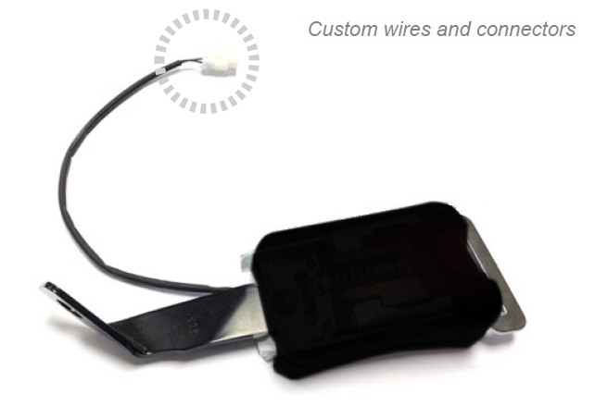

**Specifications:**

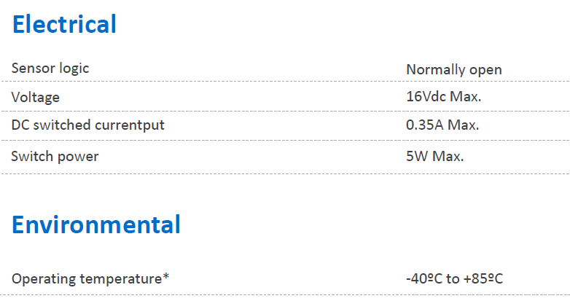

**Seat Occupancy Membrane Pressure Sensor for Car Seat**

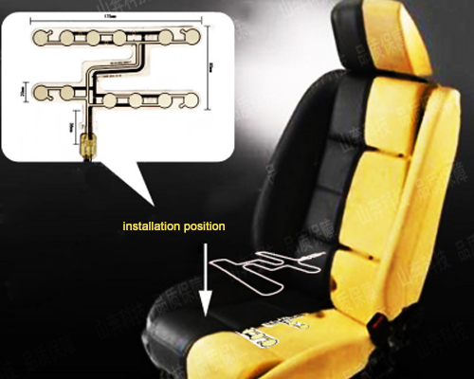

## **Specifications:**

|  |  |
| --- | --- |
| Rated Voltage | ≤50V DC |
| Rated Current | ≤ 100mA |
| Operating Power | ≤1W |
| Insulation Resistance | ≥100MΩ (250V DC) |
| Loop Resistance | 10Ω~2kΩ (based on the design) |
| Contact Resistance | 0.5 ~ 5Ω |
| Wire Lead Resistance | <1Ω/cm |
| Base Material Voltage Withstand | 1500V DC |